**Intro**

The Smith Master’s Office is the graduate studies branch of the Robert H. Smith Business School at the University of Maryland College Park. Currently, they are hoping to increase the effectiveness of their marketing investments made by Smith School Marketing Communications in attracting potential students to apply to various masters and executive programs. While relying heavily on international application in previous years, Smith hopes to grow their local presence and recognition in the Maryland, Northern Virginia, and DC area. With Amazon planning to build its HQ2 nearby, Smith is eyeing new ways to attract local talent to their student body, one of which is increasing the quality of their marketing communications. In order to increase their effectiveness we will analyze each channel to determine what works the best and make recommendations based on these findings.

In order to increase the effectiveness of their marketing efforts and best target potential students, we will utilize their available data to evaluate their current tactics. We were presented with data from the University and set forth to better understand their consumer base along with identifying potential growth opportunities and areas with room for improvement. We closely analyzed Google Display Network (GDN), Google Search, and Google Discovery data to see how the university’s audience has been perceptive to the marketing efforts that were presented to them.

Our objective is to use our analysis to be able to provide the school with sound recommendations that will lead to an increase in program interest. For the purposes of this paper, we’ll be using conversions, measured by students who filled out interest forms for the graduate programs. We plan to explain what we believe to be the best way to allocate the $100,000 budget between the channels for the programs to maximize the number of leads.

**GDN**

In analyzing the top performing ads as run through the Google Display Network, we can almost immediately identify a theme. As demonstrated in **Appendix 1**, all of the top five performing ad displays were those communicating information regarding an “Open House.” Specifically, the Open House for Master’s in Quantitative Finance appeared to perform exceptionally well. One might assume from looking at this information that banners displaying “open houses” were best performing. **Appendix 2**, which uses a PivotTable to group together results by type of display ad goes forward to confirm this theory, with open house messaging receiving higher average conversion rates.

An incorrect interpretation of this finding would be to recommend that Smith simply put forward more messaging about open houses. It helps to understand this communication in terms of the digital marketing funnel. Display ads urging users to click to sign up for an open house occurring soon could be referred to as a “down-funnel” marketing activity. Conversely, messaging with general information about degree programs, or seeking to elevate the overall status of the Smith Masters Program brand would be considered “upper-funnel”, as they impart more general information, and do not provide a call to action with the same urgency. An example of a marketing funnel is shown below, for reference.

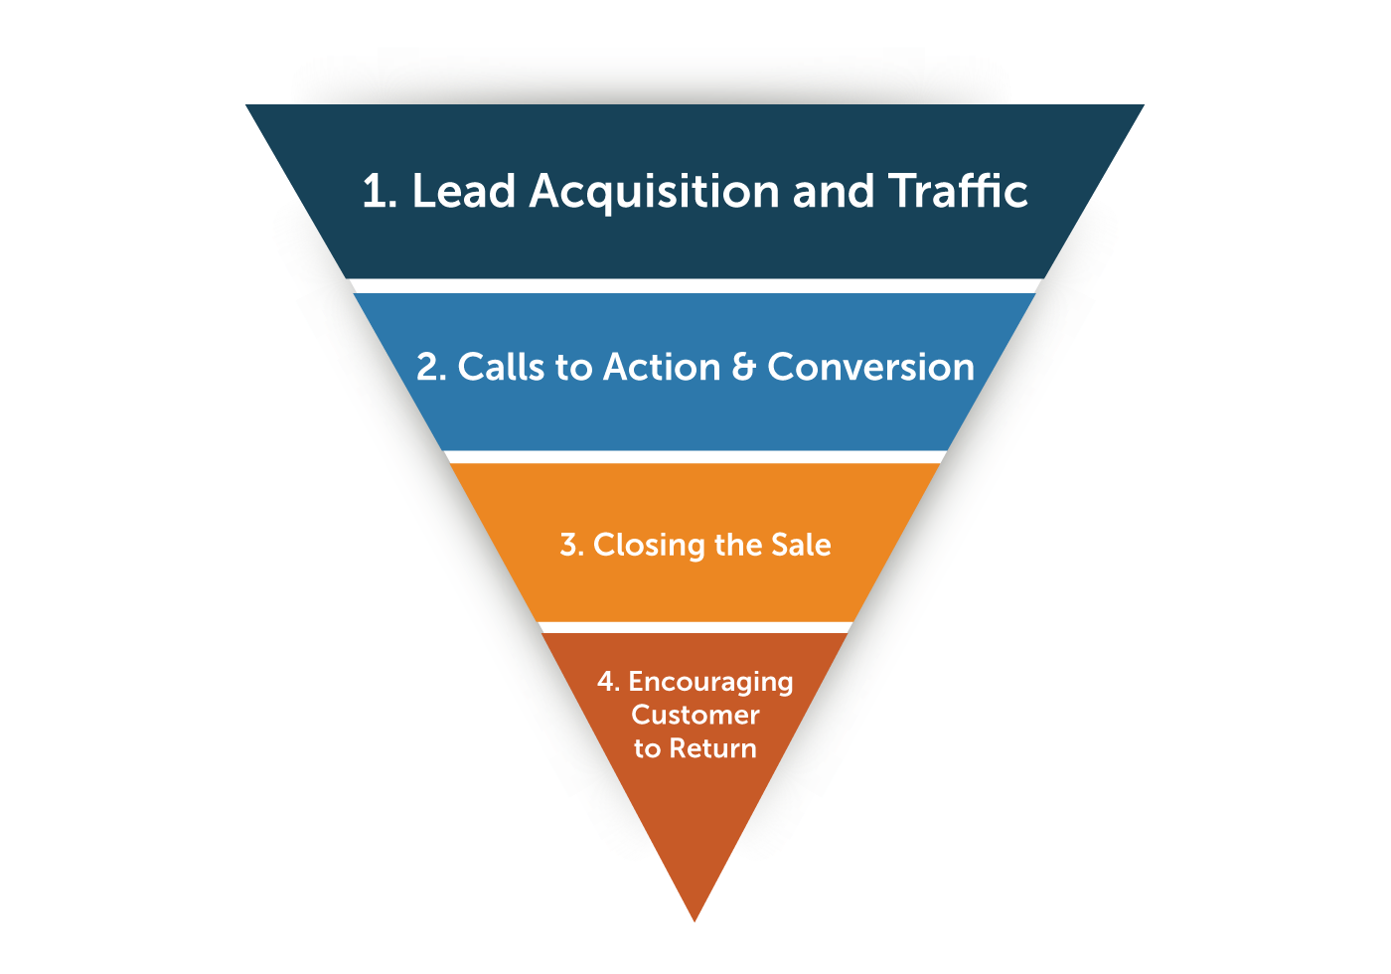

What’s important to understand about using digital conversion metrics to assess ad performance, is that doing so will ultimately reward *any* down-funnel promotions, because they’re designed to lead to digital conversions. However, this does not account for the initial awareness, education, and interest generated by the upper-funnel marketing messaging, such as the general master’s general display. While this messaging might not lead to concrete conversions, it might create greater awareness, leading to a higher conversion rate in the future. This is important to remember when making budgeting recommendations.

Next we sorted display advertising performance by audience. In **Appendix 3** we are able to compare performance between audience types, once again using high conversion rate and low cost per conversion to assess success. By far, the best performing audience designation is ‘Finance Degree Programs’, which resulted in an average conversion rate of .149, almost 15%, and a cost per conversion of 20.129. The closest followers are “Marketing Degrees” and “Business Education”, which both had a conversion rate of roughly .03, but a much higher cost per conversion, or 41.9 and 72.2.

Finally, we sorted our findings by audience type performed, as shown in **Appendix 4.** Overall, we see the best conversion rate from an “in-market audience”, of roughly .03, however it also comes with a high average cost per conversion.

**Google Search (Sherry & Jasper)**

For the Google search part we first identified the highest conversion rate and highest click through rate keywords, high conversion rate with low CPC keywords , lowest conversion rate and highest CTR keywords and lowest conversion rate and lowest CTR keywords.

1. Top 5 conversion rate keywords

* +supply +chain +management +masters (MSC)
* +quantitative +finance +program (MQF)
* +ms +in +business +analytics (MSBA)
* [masters in mis] (MSIS)
* +msis +programs (MSIS)

1. Keywords that have a high conversion rate but cheap CPC. We would recommend more investment in these words.

| Keyword | Quality Score | CTR | Conversions | Conv. rate | Cost / conv. | CPC |
| --- | --- | --- | --- | --- | --- | --- |
| +quantitative +finance +program | 4 | 2.93% | 3.19 | 35.42% | 45.99 | 16.29 |
| +ms +in +business +analytics | 5 | 1.49% | 3 | 60.00% | 28.79 | 17.27 |
| [masters in mis] | 3 | 1.37% | 2 | 33.33% | 36.94 | 12.31 |
| +msis +programs | -- | 3.17% | 2 | 100.00% | 7.79 | 7.79 |
| +ms +in +business +management | 5 | 10.00% | 1 | 20.00% | 78.26 | 15.65 |

1. Keywords with low conversion rate but high CPC. We would recommend to cut down investment or improve these keywords.

| Keyword | Quality Score | CTR | Conversions | Conv. rate | Cost / conv. | CPC |
| --- | --- | --- | --- | --- | --- | --- |
| +masters +in +marketing +analytics | 6 | 8.13% | 0 | 0.00% | 0 | 44.33 |
| [business graduate programs] | 3 | 4.33% | 0 | 0.00% | 0 | 32.80 |
| +online +ms +supply +chain +management | 4 | 4.26% | 0 | 0.00% | 0 | 32.37 |
| +masters +in +supply +chain +management +online | 5 | 3.41% | 0 | 0.00% | 0 | 63.40 |
| +ms +in +marketing +analytics | 6 | 4.05% | 0 | 0.00% | 0 | 44.25 |
| +ms +logistics +and +supply +chain +management | 3 | 7.89% | 0 | 0.00% | 0 | 38.64 |
| +marketing +analytics +graduate +program | -- | 14.29% | 0 | 0.00% | 0 | 58.36 |
| +master +of +applied +finance | -- | 2.78% | 0 | 0.00% | 0 | 32.73 |
| +best +accounting +masters +program | 1 | 1.08% | 0 | 0.00% | 0 | 26.73 |

1. Keywords with low conversion rate and low CPC : The following keywords are for broad search. The Smith google adwords obvious didn’t perform well on ranking long-tail keywords. As you can see below, they got zero clicks and have lost a high percentage of search share.

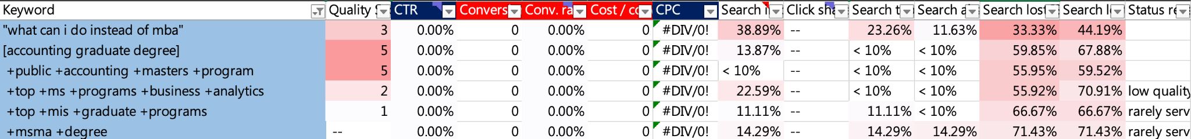

We then categorized all of the keywords into their represent programs and see how they performed betweens programs.(**Appendix 5**) We can tell from **Appendix 5** that the Master in Finance is the most popular and the Master category( those keywords search master in business management). Master of Supply Chain and Master of Marketing Analytics have a Cost per Impression that is greater than one. Within all of these, we can observe that the keyword ‘Master in Information Science’ is a great investment since it has the lowest CPM.

Create managerial KPI for each metrics

To further understand how these keywords bring in clicks, we analyzed their cost per click, click through rate and click share. We calculated the clicking average across all keywords that have data greater than 0. If the keywords’ performance is better than average, we’ll mark them as red. Over two red signs would be considered a good keyword for generating leads and conversions. **Appendix 6** shows how we calculate manually and what keywords we would recommend using.Then we further investigated those keywords with good clicking performance but lacking conversions(conversion equal to 0). (**Appendix 7**) Compared to the conversion group’s average quality score, this clicking group’s quality score is slightly lower. (4.83 vs. 4.38) Additionally, the CPC is a little bit higher than the conversion group. (23.22 vs 22.14) Only the Search lost IS (rank) and Search lost top IS (rank) is slightly better than the conversion group, which means that the probability that their ad didn't show on Google search sites due to poor Ad Rank is lower.

Besides calculating manually, we decided to offer some other machine learning models for managers to refer to when it comes to evaluating keyword performance and picking keywords. By looking for the best-performance keywords we used clustering analysis to examine the connection between costs and each of three performance metrics. The reason we chose “CTR” “Click share” “Search Top IS” as the performance metric, as each is positively related to whether a keyword eventually succeeds in competing with other keywords after launching. First we examined the sum of squared error of the model to determine the optimal number of clusters for analysis, and found that keeping three clusters would be the best option (**Appendix 8**). All the numbers in the data are demeaned and standardized so that a number larger than 0 would mean the observation is higher than the average value of that category, or conversely lower than the average if the number fell below 0. By finding the cluster for lower-than-average costs and higher-than-average performance metrics, we can determine our evaluation criteria. For example, in **Appendix 9**, cluster denoted as 1 is the ideal group because their average costs are all lower than the average. Then we filtered the “CTR” larger than 0 and six keywords were selected. A limitation of the available dataset is that there is no label variable to evaluate the success of a keyword, and we were unable to create one. So in this case, we do not know which of these performance metrics drive more “value” than the other two. Therefore, we concluded that whether the keyword exists in two out of the three metrics is the criteria we would use to recommend investment. The keywords are “+umd +mis +program”, “[masters of quantitative finance]”, “+quantitative +finance +program”, “[non mba business masters]”.

**Google Discovery**

Google Discovery is a tool that relies on machine learning to aid businesses by helping them deliver optimal performances based on their marketing objectives. By setting their bid and budget the University of Maryland's goal was to use automated bidding options to maximize conversions showing meaningful ads to people when they are most interested and ready to learn more about specialty masters programs. The audiences outlined by the University of Maryland Smith Graduate Program are: Accounting & Finance Jobs, Accounting and Finance degrees, Business Analytics courses, Business Education, Business Professionals Data Science degree programs, degree programs in finance, executive finance programs, finance degree programs, marketing degrees, masters in accounting, master in IT, masters in management, quantitative finance degrees, supply chain management degree. As these audiences browse their favorite content and feed-based experiences, Google uses machine learning to display ads to when they are most likely to interact with the ad.

As seen in **Appendix 10**, in the Discovery Channel there are only 2 audiences being converted from the ad. Anyone within 35 miles who fell into the given categories were shown specific ads provided by University of Maryland in an attempt to create leads for Specialty Master’s programs. The audience types in which they were categorized were affinity audience or in-market audience. This means that Google will reach users based on what they're passionate about and their habits and interests. In-market Audience reaches users based on their recent purchase intent. We found that Business Professionals in the affinity audience had the highest impressions as 1,418,810 impressions, 459 conversions and a conversion rate of 1.33%. The Business education audience that were in-market audience type had fewer impressions at 15,075, 6 conversions, and a conversion rate of 1.88%. Because this method is being used to acquire leads and potential students, we suggest using the Business professionals in the affinity audience as overarching catch-all to build a pipeline of leads. The Business education in-market audience could be more tailored to making quality conversions to learn more about the program.

**Comparison Between Channels**

To compare how well each channel performed against one another we created a table composed of averages for Cost, Impressions, Clicks, AVG.CPC, CTR, Conversions, Conversion Rate, and Cost/Conversion as seen in **Appendix 11**.When comparing the different channels for Specialty Master’s programs we took the average of each channel and found that for the organic search channel cost the most at $218.15, discovery came in second at $208.30, and display was the least expensive at $154.56. Discovery had the highest number of impressions at 57,355, display was second at 50,226, and the channel with the worst impressions was organic search at 238. The discovery channel had 1,394 clicks while display had 316 and search had the least at 9. AVG CPC was the highest for search at 23.13, display was 0.60, and discovery is 0.16. As it pertains to CTR search had the highest click throughs with 0.04, display was second at 0.03, and the lowest was discovery at 0.02. The display channel had the second highest Conversions at 2.24 and conversion rate at 0.02, and the highest cost per conversions at $38.16. The highest in conversions was discovery at 18.60, but the lowest average conversion rate of 0% and cost/conversion at$0.79. Although search had the second highest cost per conversions at $33.92 and the highest conversion rate at 0.05, it had the lowest amount of conversions at 1.2.

**Recommendations/Plan**

Based on our results from the data which showed higher conversion rates for display ads for open houses along with being inexpensive in comparison to other ads like the general display one. Since the open house advertisements have a clear call to action for recipients, they are more likely to result in a conversion. We concluded that display ads with a clear call to action or display ads that inform the recipients about a specific event have a higher conversion rate and should be looked into more closely, as they also indicate the performance of “upper funnel” messaging as well. We’d recommend using a combination of displays containing strong CTA messages and “brand building” activities, such as sending Smith reps to local undergraduate business programs, partnering with companies and start-ups in the area, and using brand-based display messaging. Combined with “down funnel” banner ads with strong CTA’s, we believe Smith can leverage advertising to build a strong pipeline of interest. If the University puts out more information pertaining to on campus events while still providing their audience with the general display ads that provide the initial interest and information, the conversions will increase. The data also showed that the highest conversion rates for display ads were those that showcased the Finance Degree Programs, followed by the Business Education programs. We recommend investing in more specific display advertisements that would target these degree programs to lead to an increase in the conversion rates of their advertisements.

Lastly, for display advertisements we observed how each audience type performed. The highest average click through rate audience type was “in-market audience.” To improve upon this we recommend a continued effort in reaching out to the “in-market” audience to increase the click-through rate, which could lead to a higher number of conversions which would lower the average cost per conversion since it’s so high. Retargeting the in-market audience after already reaching out to them with the general display ads that provide the initial interest, with open house opportunities or on-campus event information would maximize conversions while lowering cost per conversion for example.

In determining the optimal investment in Google keywords search, we defined a criteria of keywords that have a high conversion rate and inexpensive CPC, and these keywords are what we would recommend further investment in. The keyword combination “Quantitative Finance Program” has the highest number of conversions among all the available keywords, also “MSIS Program” is the most cost-effective combination since the costs versus conversion is the lowest. To improve Google Search performance we recommend reallocating the current keyword search investment portfolio by lowering investments in keywords that have low conversion rates and focusing more on the keywords that yield higher-than-average conversions and lower-than-average CPC. In addition to that, we created cluster models that are able to examine three performance metrics along with their costs by categorizing the observations into groups. Using this approach will significantly help us in pinpointing the best-performance keywords, the detailed interpretations of which are in the Findings of Google Search.

**Allocation of Budget**

We recommend investing a total of $30,000 of our allotted $100,000 budget to use with Google Display Network, more specifically investing in the display ads for the Finance Degree & Business Education programs, as well as a continued effort in reaching out to the “in-market” audience and creating general display ads that’ll generate interest in the various programs before implementing displays with a call to action (like an open house) to maximize the number of leads that the University obtains. We think $30,000 should be invested into the Discovery channel since it had such a low conversion rate. We think it deserves this allocation because it would be a great opportunity to build a pipeline of Affinity Audience Business Professionals and In-Market Business Education as leads for Universities to reach out to about Specialty Masters programs.This targeted approach can help the school save money by only showing ads to people when their most interested in seeing it. Finally we think it would be best to allot $40,000 to the paid search channel, since it had the highest conversion rate. We think this would be the most useful for capturing individuals interested in Specialty masters programs further down the pipeline than those captured by the Discovery Channel. These individuals would be actively collecting information about secondary education programs and would be more susceptible to interact with additional marketing outreach.

**Appendix**

Appendix 1: Top 5 Display + Audience Combinations, Per conversion Rate

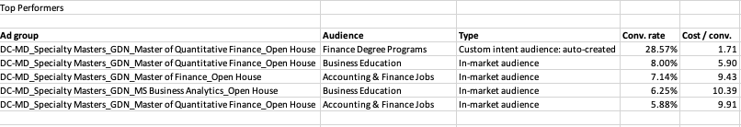

Appendix 2: Performance per Display

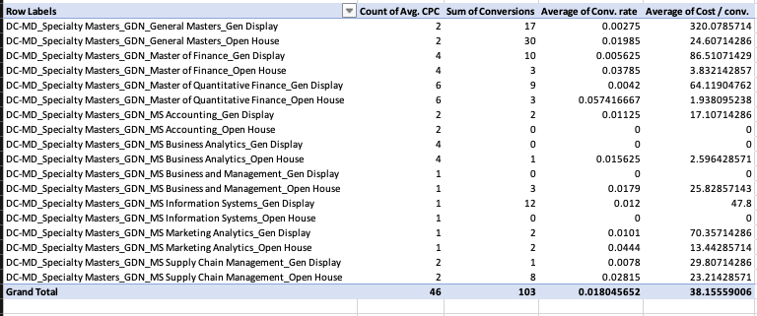

Appendix 3: Performance per Audience

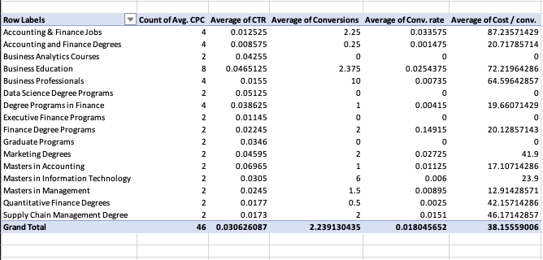

Appendix 4: Performance per Audience Type

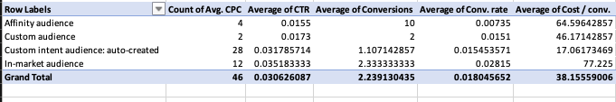

Appendix 5: CPM comparison between programs

| **Specialty Masters** | **Total - Impr.** | **Total - Cost** | **CPM** |
| --- | --- | --- | --- |
| MA | 1,452.00 | 789.67 | 0.54 |
| Master | 6,850.00 | 8,545.66 | 1.25 |
| MF | 7,520.00 | 6,368.90 | 0.85 |
| MQF | 698.00 | 400.50 | 0.57 |
| MSBA | 2,040.00 | 1,798.61 | 0.88 |
| MSC | 2,293.00 | 2,720.84 | 1.19 |
| MSIS | 612.00 | 177.61 | 0.29 |
| MSMA | 504.00 | 867.53 | 1.72 |
| **Total** | **21,969.00** | **21,669.33** |  |

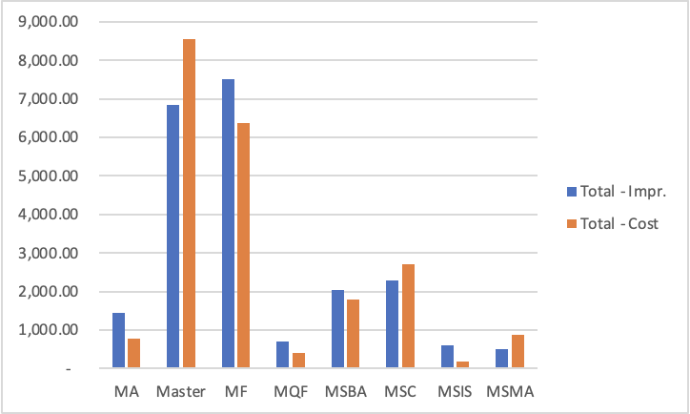

Appendix 6 : Manually calculated KPI for managerial decision

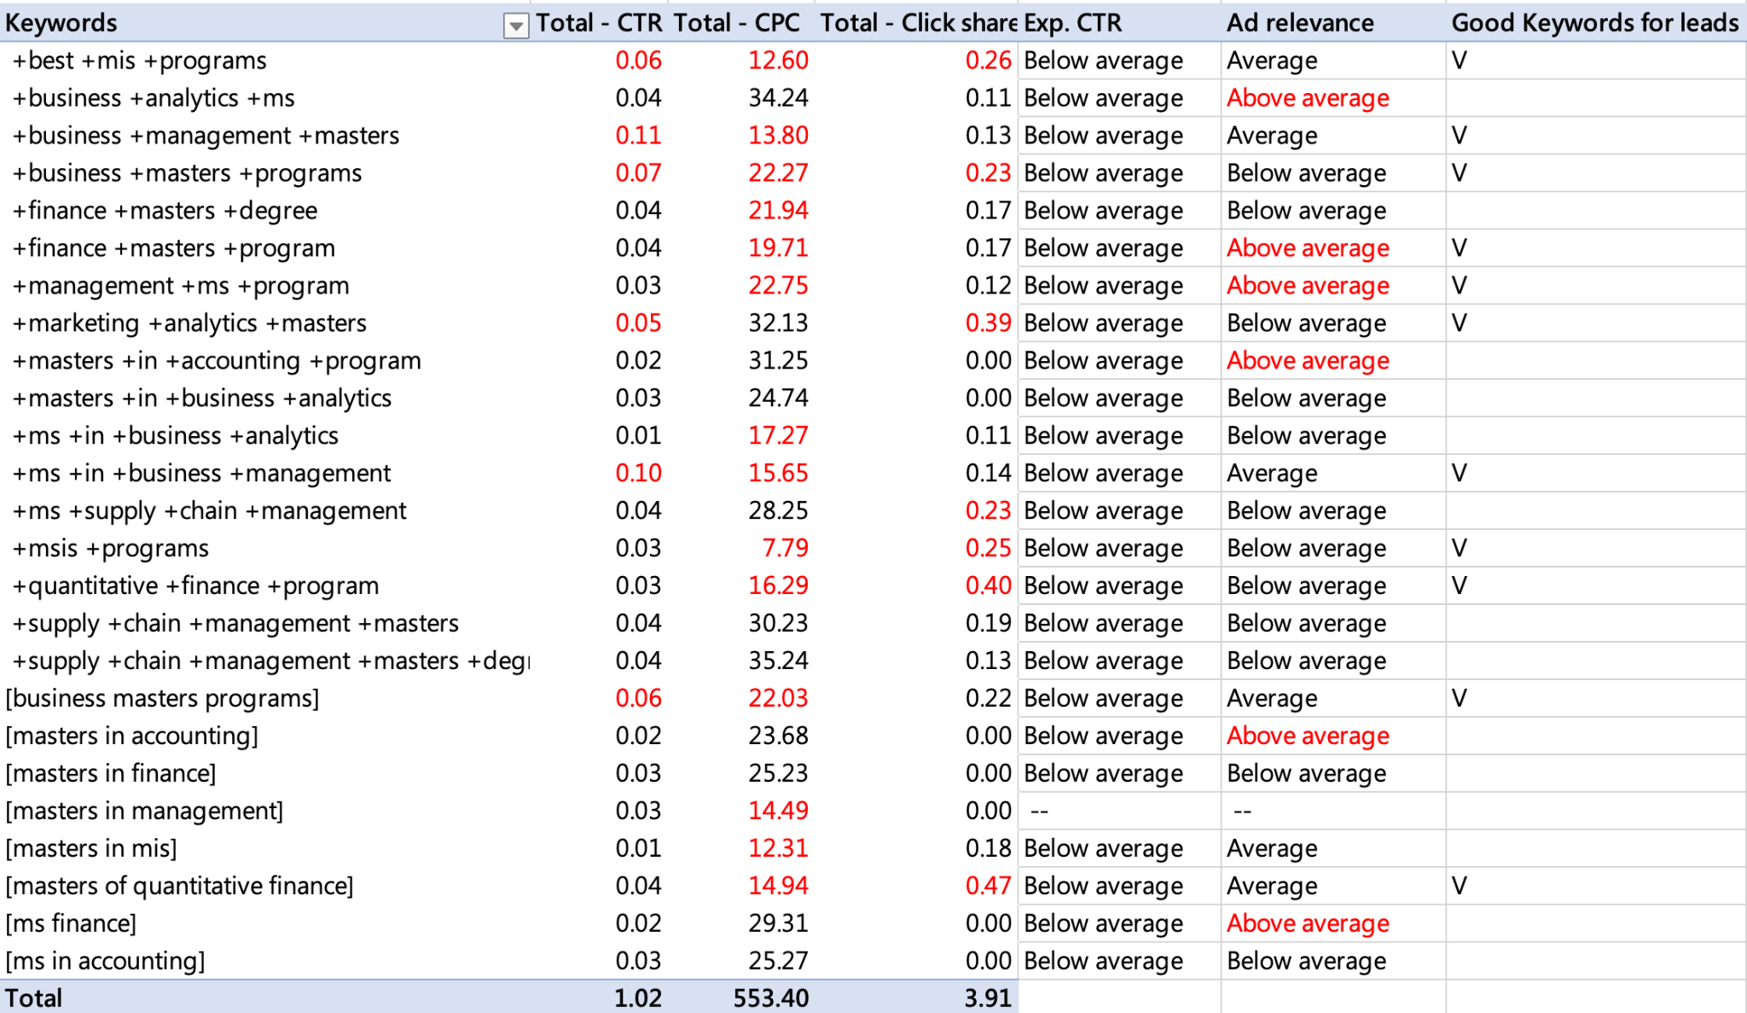

Appendix 7: Keywords with low conversion rate but high CTR

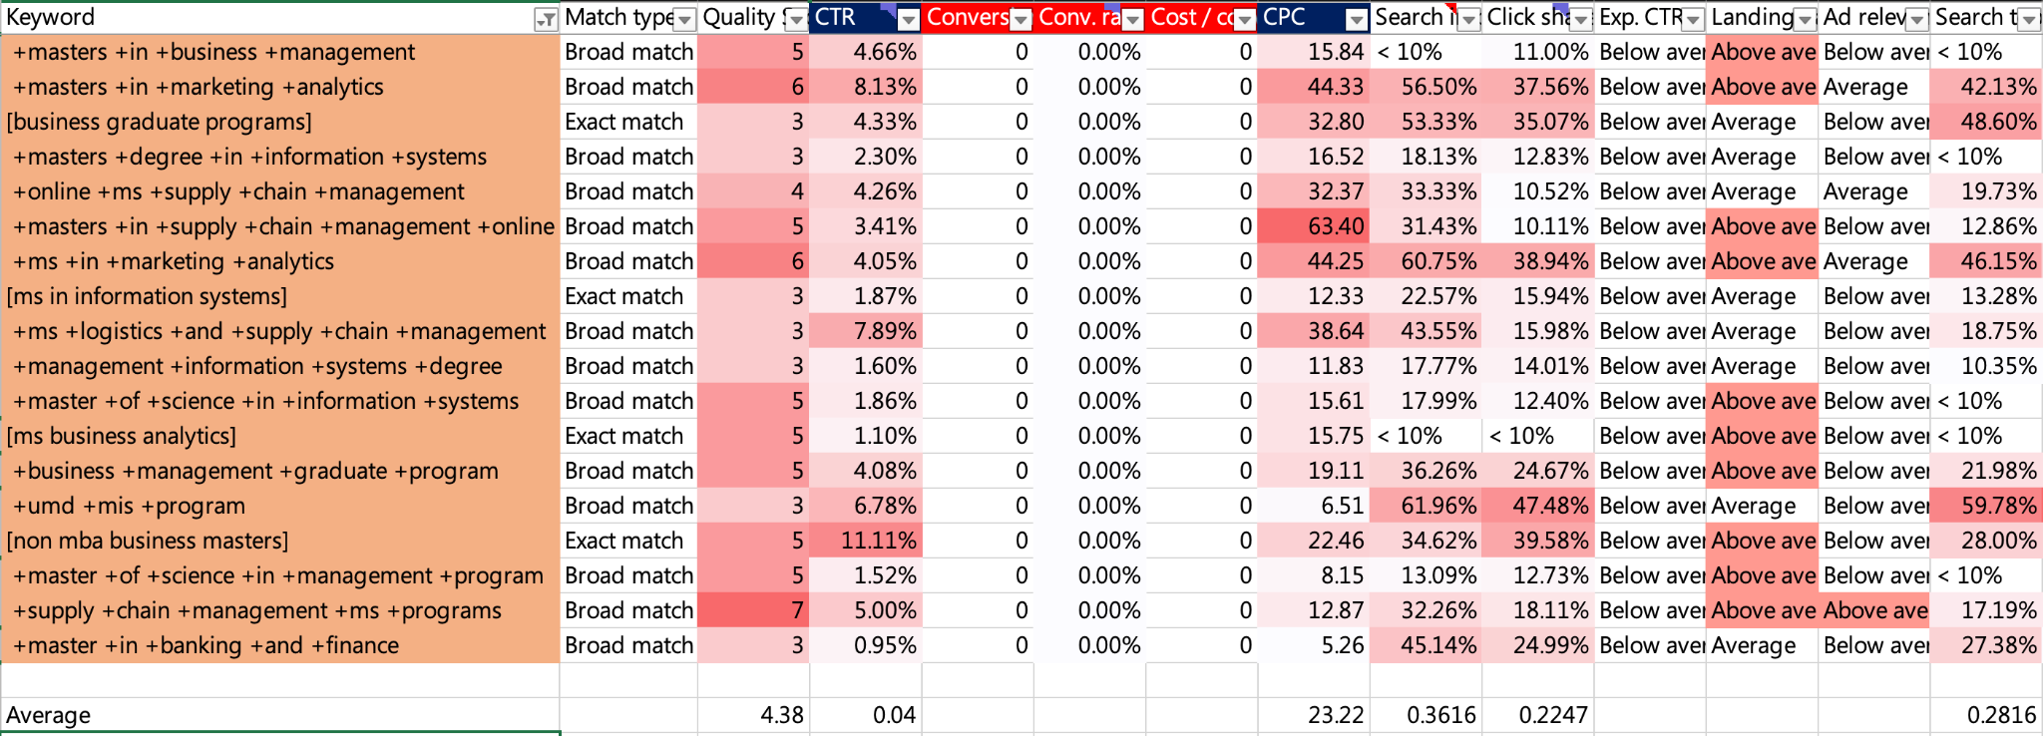

Appendix 8: SSE Elbow plot of Clustering Analysis

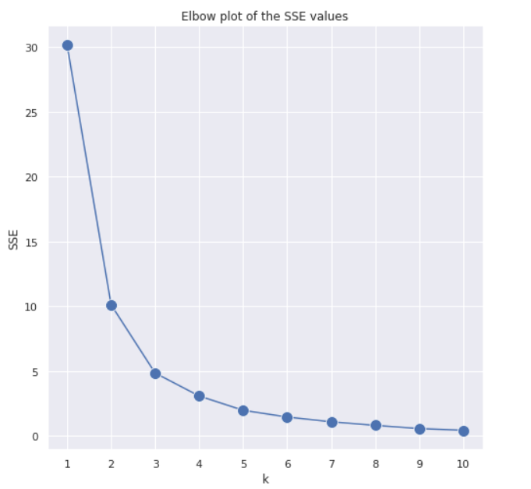

Appendix 9: Cluster means scatter for Average costs and CTR (example)

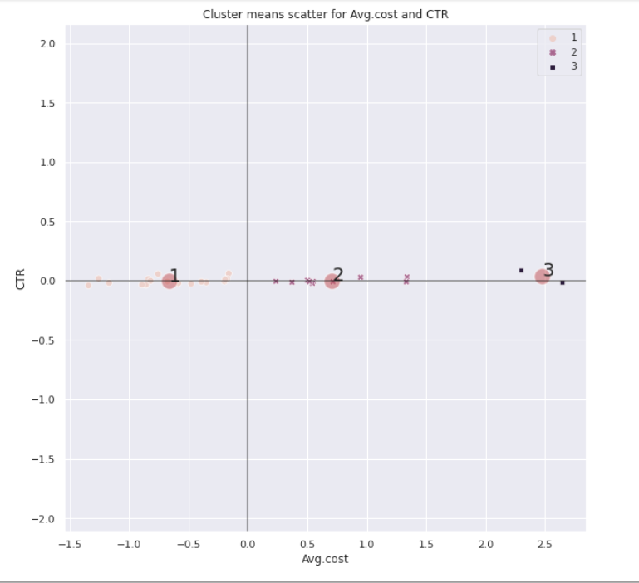

Appendix 10: Specialty Master’s Discovery Channel



Appendix 11: Comparison between channels

